**Day 1 – Assignment**

**Pratik K Kamble**

**Employee ID : 46263548**

**09 – 09 – 2022**

**Q1:** You need to create a simple application. Name your main class as SampleOutput.java. When you run your main class. You should get output as below.

“Hello, Pankaj.”

“Hello, Java.”

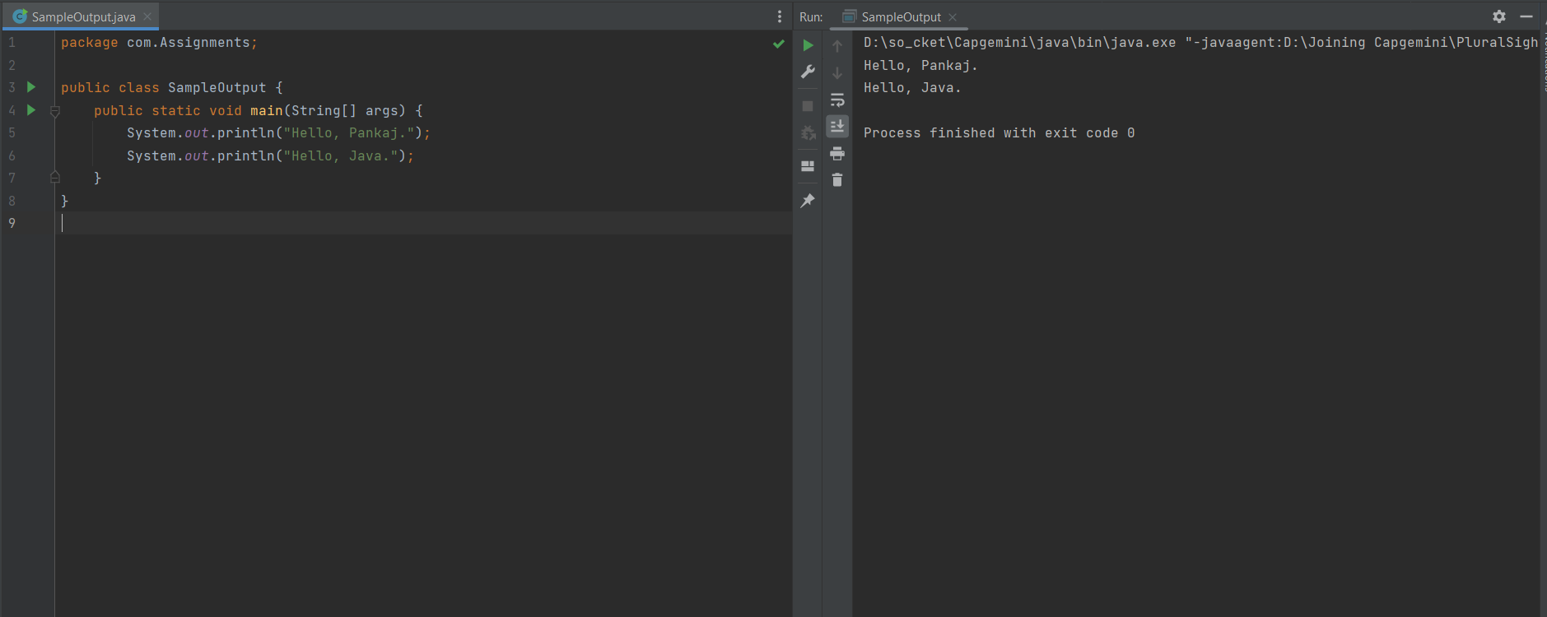**Solution :**

**Q 2**: Most of the java apps will require the input from the user. That, we will be learning later as well. Right now let us focus on strategy to take input from user and display that on console.

Scanner scanner = new Scanner(System.in);

String str= scanner.next();

int num= scanner.nextInt();

scanner.close();

System.out.println("String is: " + str);

System.out.println("Num is: " + num);

**Extra Task**: Explore Scanner on **jdk api doc**

Here through Scanner we are taking the input from the standard input. Using scanner, we use various methods to take specific type of input, such as String, int, float etc.

scanner.close() specify the termination of stream and says there is no more need of tacking input from console.

Below two output lines display the output of the string and number entered by user.

Your task is to take the input of the below requirement.

**Solution :**

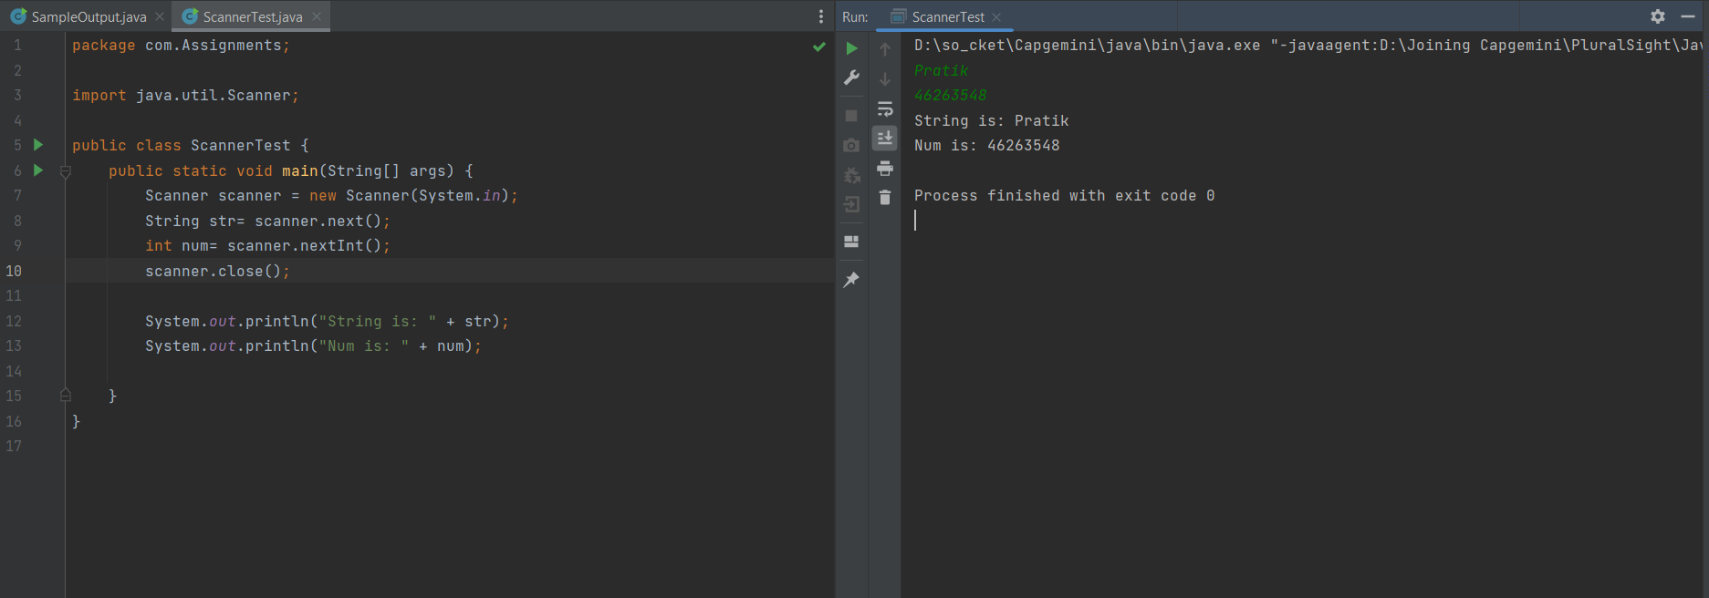

**Q3**: Assume we are working on Product Management app, where we need to enter the product based details in the system. Such as productName, MRP, Selling price, and discount provided. We are assuming the output as below.

Output:

Sr # Product Name MRP Selling Price Discount

--------------------------------------------------------------------------------------------------------

1 Headphone 500 400 20

**Solution** **:**

